INTELLIGENT BASE ISOLATION: A REVIEW

Ryan Skelly, B.S. Civil Engineering Building Science,
M.S. Structural Engineering (Candidate)

ABSTRACT

Intelligent Base Isolation is vital to preserving both large scale and small scale structures in the event of earthquake caused ground excitation. In order to assess the effects that earthquakes have on structures and soil, it is necessary to understand soil structure interaction, as well as the ways in which buildings in proximity have feedback with each other as well as the soil structure below. By exploring the relevance of ground motion in relation to soil structure interaction, different forms of intelligent base isolation technology can be developed to resist incident surface waves and the effects of soil structure interaction, which include structural base isolation, computational base isolation, and geotechnical base isolation methodologies. Although each of these fields of intelligent base isolation have multiple differences in application to reducing the effective earthquake acceleration within a structure, the end goal is the same: how well can innovative base isolation technology improve a structures performance in an earthquake in order to reduce structural damage as well as human injuries. Through exploration of each of the three main times of intelligent base isolation, it becomes clear that geotechnical base isolation provides a combination of features that motivate the need for future development and experimentation to not only optimize the technology, but to begin large scale implementation in areas with high seismic risk.

1. Introduction

In order to protect structures from the effects of earthquake wave propagation through soil, the foundation, and the structure itself, researchers in Civil Engineering are constantly developing and advancing research to preserve a structure’s integrity during an earthquake event. This process of structural preservation is known as base isolation, in which civil engineers seek to isolate the base of a structure from the above ground building envelope or isolate the foundation and structure together, allowing for resultant earthquake wave forces to be mitigated.

To begin understanding the importance of base isolation technology to the field of structural engineering, it is vital to understand that, as of now, there is no perfect equation or model that can take the expansive number of variables involved in earthquake analysis and produce a completely earthquake resistant structure. In fact, the world of civil engineering at this moment is on the opposite side of perfection in design, as there is a great distance between leading methods of advanced earthquake design and the codes to which the majority of structural engineers’ design standard structures. The codes that govern structural design guidelines often overlook the various ways in which earthquake forces can be both magnified and in a structure through soil structure interaction and mitigated through the use of intelligent forms of embodied wave energy reduction, otherwise known as base isolation. In terms of magnification, standard building codes do not take into account elements such as soil structure interaction which causes wave amplification, resulting in larger seismic forces to become incident in a given structure. In terms of mitigation, standard codes offer little to no insight on existing and experimental technologies which are able to effectively reduce the effect of earthquake waves as they enter a structure, or even before these waves come in contact with the foundation of a structure. As of current, it seems as if building code committees are unwilling to change their inadequate methods of design, and thus it becomes important for structural and earthquake engineers alike to be made aware of the existing and developing base isolation technologies of the modern age to not only protect their structures, but also to protect valuable human lives.

In order to provide an overview of intelligent base isolation technology, current methods of base isolation that are developing or already developed are split into three sections due to similarity in theory and implementation in or around a building envelope. The most prevalent form of base isolation that is used today, known as structural base isolation, separates the foundation from the above building structure and employs mechanical methods of seismic force reduction through damping, stiffening, or sliding of elements in the structure. Another form of base isolation, known as computational base isolation, combines the use of structural base isolation with active control systems that work together to provide a specific response to individual structural excitation events by utilizing computerization to process real time wave data and modify the stiffness or damping in a structure for optimal seismic force reduction. The final form of intelligent base isolation technology explored, known as geotechnical base isolation, takes a different approach in that the geological infill located around and underneath the foundation of the building is modified to reduce wave energy prior to the earthquake wave reaching the entire building envelope, resulting in more comprehensive structural protection. These methods will first be analyzed to confirm whether they are, in fact, an intelligent form of base isolation, and further analysis will examine the technology’s ability to reduce earthquake response with and without the effects of soil structure interaction, as well as considerations for technological longevity and long term resistance to multiple major earthquake events. In the end, one form of base isolation technology will be recommended for more research and development based upon the above criteria and future possibilities of more complex development to provide optimal structural protection.

2. Effects of Earthquakes in Structural Excitation

In order to develop methods of earthquake wave mitigation due to actively reducing resultant earthquake forces, it is necessary to understand the various motions that structures will incur in the event of an earthquake, and which elements of an earthquake cause such excitations. Although the ultimate goal may be to reduce seismic forces in a structure, it is important to understand that forces delivered to the structure are from the resultant ground motion after the event of an earthquake. When a fault slips, multiple waves are sent outward from the slip plane, which are broken into the categories of body waves and surface waves, which will further be broken down in the subsections.

Thus, in order to develop the most effective technologies it is important to understand which waves cause the most amount of structural excitation as well as the characteristics of each wave’s motion that cause the effective movement of the soil and structure. From observing the effect of different waves on the soil and structure, new theories have been developed on the interplay of soil and structure on the resultant deformation of a particular structure during an earthquake. This has an effect on intelligent base isolation design, as considerations of soil structure interaction (SSI) must be included because the role of this interplay can change structural response significantly, undermining the usefulness of many base isolation techniques.

Along similar lines as the role that SSI has on structural excitation, the concept of structure soil structure interaction (SSSI) is vital to understanding the response of structures in a highly populated area where adjacent structure’s motions can affect the response of both soil and structure due to changes in earthquake wave signatures due to wave reflection and refraction. Despite the complex interplay that soil and adjacent structures have that cannot be fully calculated, it is possible that some forms of base isolation technology can adjust for these wave changes despite not being able to calculate for exact expectations of structural response. Thus, considering important wave signatures, as well as soil-structure interplay can aid in developing the most comprehensive form of wave reduction technology for different methods of intelligent base isolation, which will be explained in greater detail.

2.1 Structural Excitation as a Result of Earthquake Waves

Body waves, such as P Waves and S Waves, travel through the earth’s interior and travel at higher speeds and carry a higher frequency than surface waves. The first wave to arrive after an earthquake, which is the P Wave, known as the primary wave, is little concern for intelligent base isolation as this compressional wave often does not cause damage to a structure [1]. Similar to P Waves, S waves, otherwise known as secondary waves, do not cause a great deal of damage to an engineered structure [1]. This type of wave moves ground particles vertically, causing vertical and horizontal motion as a result. Thus, due to weak overall forces, body waves are not of primary concern to the development of intelligent base design, and will subsequently be ignored in overall analysis.

Surface waves, such as Love Waves and Rayleigh Waves, differ greatly from body waves in that they travel along the surface of the earth in the crust layer. These waves embody most of the energy produced from an earthquake and must be understood in order to develop intelligent base isolation technologies [1]. The first type of surface waves, known as Love Waves, move the ground from side to side, causing horizontal motion of particles in a sinusoidal manner [1]. However, despite the danger of Love Waves, Rayleigh Waves are the main cause of significant damage in a structure, particularly due to the resultant ground particle motion that is induced [1]. Unlike any other type of wave resultant from an earthquake, Rayleigh waves induce both horizontal and vertical ground motion, resulting in ground particles to move elliptically and in a somewhat unpredictable manner. In essence, this wave moves similarly to how waves move in liquid, causing the most severe levels of damage and resultant building excitation.

It is therefore vital to choose a wave which results in the largest amount of structural excitation for the design of intelligent base isolators, and in many cases, the study of the SH pulse, a form of surface pulse incident from an earthquake and often the most damaging form of excitation is necessary [2]. A study on the effect of the SH pulse in non-linear soil deformation evidences that the consideration of non-linear deformation in the soil substructure is a more efficient form of base isolation than previously considered, thus evidencing that it is possible to take advantage of the soil substructure as a base isolator [2]. This study also evidences that considering the use of a flexible foundation in design is important to reducing the effects of an SH pulse as wave energy dissipation is optimized through mechanical means of reduction in the soil-foundation substructure [2]. Thus, this observation of the power of the soil and foundation in reducing wave energy evidences the need for development in substructure related base isolation methods in opposition to the standard methods that utilize structure-foundation methods of wave energy reduction.
Thus, the importance of understanding the power of surface waves, along with the harmful effects of an SH pulse, cannot be undermined in intelligent base isolation design, calling for structures to mitigate the resultant forces from these waves. It is therefore important to understand that these waves propagate soil motion in an extremely complex, non-linear manner and thus the response of the soil around a structure and its foundation is another vital element in improving methods of intelligent base isolation. Through the exploration of the effects of SH waves paired with a flexible foundation and soil substructure intended to go non-linear in an earthquake event, it becomes clear that the use of base isolators located in a structure may not be the most optimal method of design as considerations for soil structure interaction are not accounted for.

2.2 Importance of Soil Structure Interaction (SSI)

In the past, the effects of soil structure interaction (SSI) were deemed unimportant by researchers, as there was no experimental way to determine the dynamic interplay that structure and soil has on one another. However, recent developments in research have unveiled that, in fact, the effects of soil structure interaction can cause unforeseen earthquake forces in a structure, as the interplay between soil and structure tends to amplify waves as a result of wave refraction by the structure itself.

Soil structure interaction causes a great deal of concern for current methods in seismic design, as standard design procedures neglect to account for the refraction of earthquake waves by the structure [2]. In fact, if the interplay between structure and foundation is ignored, the engineer is essentially oversimplifying and thus under designing a structure in the event of a severe earthquake and overarching structural damage can occur far past what the design limit states would have expected [3]. As an experiment on the effects of SSI on a reinforced concrete bridge concluded, errors in strength calculations for the bridge that utilize a frequency-dependent method of calculation representative of the effects of SSI conclude that for lower shear velocities, higher mean frequencies, and a soft soil composition, the fragility limit state of the bridge was underestimated by 60-80% [3]. The results of certain foundations passing a fragility limit state that would result in failure considering the effects of SSI that were not used in the initial design of the particular reinforced concrete bridge structure used in analysis can be seen in Figure 1.
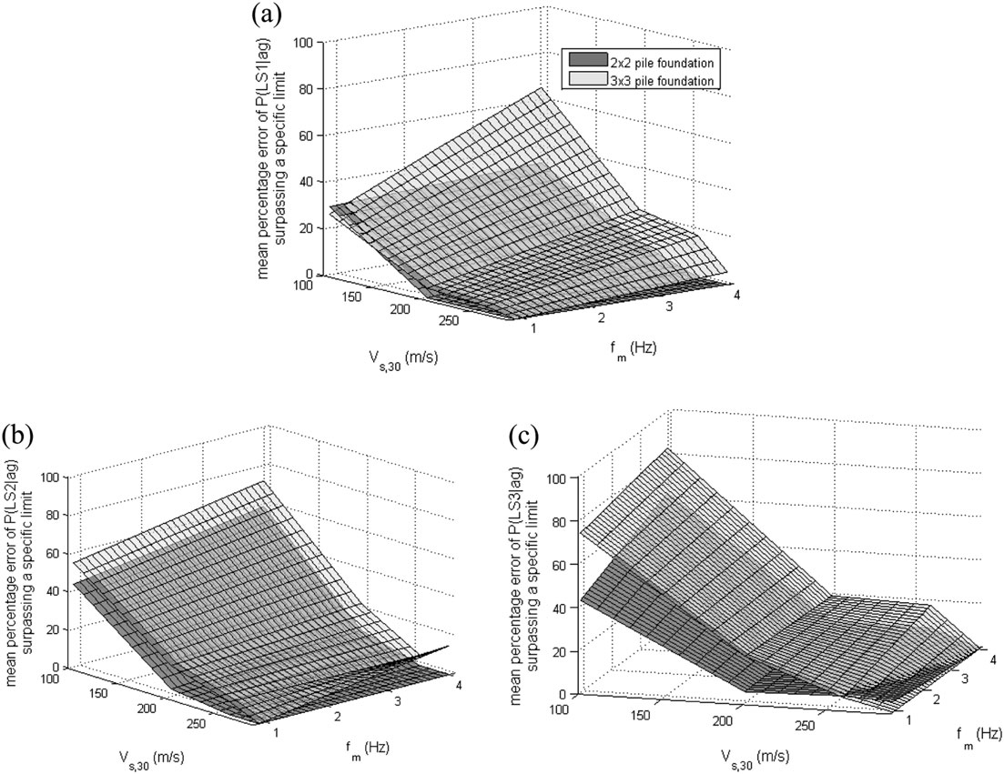

Figure 1: Probability of passing strain and/or displacement limit states for (a) serviceability limit state, (b) damage control limit state, and (c) collapse prevention limit state [3].

Thus, the role of soil structure interaction in structural design must be accounted for, as the resultant amplification can take structural performance well out of an acceptable range for use, damage, and collapse, as the results of an experiment on integrity of reinforced concrete bridges with SSI accounted for concluded [3].

Further explorations on the effects of soil structure interaction on structures offer additional support for the ways in which structures can experience additional deformation displayed by additional modeling considering response with and without the effects of SSI. With respect to intelligent base isolation technology, an experimental study using numerical analysis reveals the importance of natural frequency ratios of structure relative to soil which proceeds to evaluate the effectiveness of a retrofitted structural isolator known as a high damping laminated rubber isolator (HDLR) [4]. The numerical model created assumes a rigid foundation while the natural frequency ratios of structure to soil reflect response in stiffer soils compared to softer soils [4]. The results of this experiment conclude that the effect of SSI on modification of the incident wave frequencies lessens the effectiveness of the isolation system, indicating that the damped period of vibration, the damping ratio for an un-isolated system, and pier displacements of the foundation increase due to SSI effects, which can be seen in Figure 2 [4].
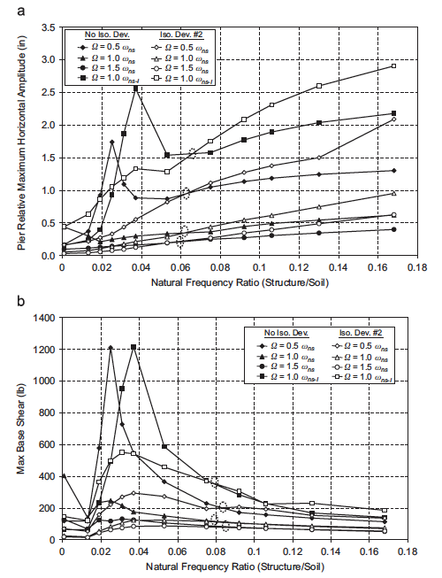
Figure 2: Isolated vs. Non-Isolated structural response in (a) pier displacement and (b) maximum base shear [4]. Note: Soil stiffness decreases as natural frequency ratio increases

Thus, the properties of the soil-substructure and foundation change due to SSI considerations, resulting in overall damping effectiveness improving for the HDLR base isolator only in stiff soil, whereas softer and medium stiffness soils reduce the effectiveness of the base isolator due to larger effects of soil structure interaction [4]. The results of a similar experiment which explores the effect of SSI on isolated bridges agrees with the results of the HDLR base isolator, concluding that SSI will increase displacements in lead-rubber bearings, another form of structural base isolation system [5]. Further observations are made in the importance of flexible design, concluding that the effects of SSI are increased for stiff bridges, stiff isolation systems, and stiffer soils [5]. The results detailed in these experiments indicate that structural forms of base isolation may not provide damping in an earthquake event if it was designed without SSI considerations and that utilizing a softer soil to support a structure inherently reduces deformation and base shear due to SSI wave energy absorption, also providing insight on the importance of flexible design. Therefore, the effects of SSI can truly not be ignored in selecting effective methods of intelligent base isolation.

2.3 Effects of Structure-Soil-Structure Interaction (SSSI)

Structure-soil-structure interaction (SSSI) and the theory behind this development in dynamic structural response in the event of an earthquake is largely based on the fundamental effects of soil structure interaction (SSI) on a singular structure. However, this method of evaluating structural response differs from SSI in that other structures, particularly buildings, and their reflected earthquake waves can cause increased structural excitation when the structures are in proximity to one another and are different heights [2]. The theory behind this insight into the effect that proximate structures of different heights had on one another derived from the same basic understanding of reflected waves in the development of SSI, which is that the structure of a building reflects waves back into the soil, thus amplifying incident earthquake waves. SSSI theory then takes this understanding and utilizes it at a larger scale, eventually discovering that proximate buildings as a whole inform the structural response of nearby buildings through wave reflection and motion of the soil particles due to both the surface waves and motion of the foundation of a building undergoing seismic excitation [10].

In order to provide a scope for the importance of SSSI, one must understand that major population centers in seismically active areas often have a dense urban setting with differing building heights and masses that have a dynamic interplay on an individual structure’s response. In an experiment where buildings were scaled down to relative sizes while maintaining a constant mass from building to building, two were placed near each other at a distance of one foundation width apart and tested on a shake table to determine the effect that SSSI would have on the amplification of spectral power [6]. While different height ratios produced differing effects on spectral power amplification, it is noteworthy that a building which was 10% taller than the reference building caused a maximum increase in spectral power amplification of 56% with an observed error in calculation throughout the multiple trials in the project being around 7% [6]. Thus, the project proves to not only be accurate in terms of experimentation, but also reveals that adjacent buildings could have a massive effect on seismic forces observed within a structure, causing a great deal of doubt in current design methodologies.

Thus, it becomes important to attempt to reduce the effect that an earthquake can have on a structure through intelligent base isolation, as current methods in earthquake design tend to underestimate seismic forces. Therefore, with advanced methodologies in base design, it becomes possible to reduce a massive amount of earthquake forces within a structure, causing the structure to perform how it was intended to and with the intended levels of seismic excitation covered in the original structure’s design.

3. Structural Base Isolation Technology

The most conventional form of base isolation technology, known as structural base isolation, is employed via modification of the structure’s attachment to the foundation, effectively reducing the incident seismic forces as they are transmitted from the foundation into the rest of the structure. Through either the implementation of stiffness/damping or sliding/friction structural base isolation mechanisms, the response of a structure can be reduced; however, findings conclude that structural forms of base isolation are not effective for SSI considerations [4,5]. As indicated in section 2.2, structural base isolators become either ineffective or worse at reducing structural deformation and base shear with considering the effect of SSI, rendering structural forms of base isolation non-intelligent and not relevant to a review of intelligent base isolation techniques.

4. Computational Methods in Base Isolation

Computational methods in base isolation utilize a combination of programmed control mechanisms and structural base isolators to create an optimal system that actively responds to earthquake excitation. In relation to analyzing the effectiveness of intelligent base isolation systems, semi-active control systems provide a different type of intelligence other than design, which is the use of computer optimization to reduce a buildings response by adjusting in real-time to current conditions and vibrations. Thus, through the use of artificial intelligence in structural protection, computational methods offer a futuristic outlook on earthquake design in buildings, leaving much room for improvement in this method. Currently, there are few computerized base isolation system types that have been implanted in structures, therefore it is deemed useful to review and analyze the most common computerized intelligent base isolation technique: the semi-active control system.

4.1 Semi-Active Control Systems

Semi-active control systems offer a combination of both computerization and structural base isolation systems which effectively improve the performance of structures in an earthquake event. Instead of relying on purely mechanical reactions to an earthquake excitation, semi-active control systems respond to incident vibrations and surface wave frequencies by modifying the stiffness of the mechanical base isolators used in the system [7].

In a study concerned with the use of fuzzy sliding-mode control, a form of semi-active control, multiple benefits were observed in the utilization of a computerized system in comparison to a standard structural base isolation system. An eight story shear building was tested among different loading conditions during two earthquake events, and a tendon system with an actuator was utilized in order to reduce vibrations resultant from earthquake wave impulses [7]. This system was designed with crossing tendons, attached to the beam-column connections on the first floor and at an actuator which is able to either reduce tension or increase tension based on earthquake excitation input [7]. Thus, mathematical equations were developed to model the active tendon system, as well as in designing the sliding-mode controller and the fuzzy sliding-mode control [7]. After the mathematical relationships amongst the tendon system and controllers were finalized, testing began on the building model.

Results from testing on the eight story building model revealed that the fuzzy sliding-mode control system was effective in reducing displacements from story to story; however, the results of this experiment were primarily focused on the difference in displacement of the eighth floor with and without semi-active control [7]. The first result for difference in displacement, simulated under the earthquake wave signature from Düzce earthquake records, was significant in that average displacements decreased from 12 cm without base isolation, to 3 cm with semi-active controlled base isolation [7]. A similar result was produced in the case of the Bolu earthquake records, decreasing displacements from approximately 9 cm to 3 cm of displacement under fuzzy sliding-mode control [7]. Thus, this form of intelligent base isolation lends itself to be functional in the event of an earthquake, minimizing story displacement and therefore reducing inter-story drift.

Although semi-active control systems have the possibility of future advancement to combine structural base isolation technology with computerization to create an “intelligent” system for base isolation, issues arise when considering the longevity of computerized elements. In many cases, electronics involved in a semi-active form of structural control will break or become non-functional due to use and overall longevity of electronics quite frequently, most likely on a 10-year basis. Thus, it becomes necessary to replace elements within the computerized base isolation system, which is difficult to do as older parts will be difficult to find, and a pieced together system could result in errors in structural control, rendering the system ineffective. Therefore, although this type of system has positives for structural control as well as an intelligent method of controlling vibrations, considering technical longevity causes issues with this system and could affect both performance and practicality.

5. Geotechnical Base Isolation Technology

Geotechnical base isolation differs from conventional structural methods of earthquake force mitigation. These forms of base isolation attempt to reduce the effective impact of earthquake waves before they get to the foundation, resulting in the entire structure and foundation seeing less overall earthquake force. In order to successfully achieve earthquake wave reduction in the entirety of a structure’s envelope, advanced developments in material science research must be concluded, as geotechnical structure isolation no longer deals with mechanical systems that separate the structure into a subterranean base and an above ground podium.

In order to reduce the effect of earthquake waves before they arrive at a structure, geotechnical isolation deals with utilizing large amounts of synthetic materials as geological infill to essentially create an earthquake barrier around a structure. Although this technology is largely experimental, it offers an approach that structural base isolation technologies are unable to satisfy which is overall protection of the whole building envelope. Thus, geotechnical methods have the ability to not only ensure safety for the exterior structure, but also the subterranean base which is still considered vital to a structure’s overall integrity.

Unlike structural base isolation, geotechnical methods of base isolation are not concerned with sliding and friction applications, as the nature of geotechnical infill serves to dampen the earthquake wave pulses, and thus dampening applications will be of primary interest to this method of base isolation technology. In order to provide an outlook on the topic of geological infill in terms of earthquake wave reduction, granulated rubber-soil technology as well as metamaterials functioning as seismic shields will be discussed as the two primary means to achieve wave energy dissipation in a structural context.

5.1 Granulated Rubber-Soil Mixtures

In order to reduce the effective forces and vibrations resultant from an earthquake event, researchers have been attempting to understand how a soil replacement or a soil composite could be utilized as a wave reduction mechanism. In recent years, granulated rubber-soil mixtures have been found to offer a combination of both stability and effective surface wave energy reduction, particularly due to the elastic qualities of rubber and the semi-elastic qualities of soil. In effect, granulated rubber-soil mixtures serve as a method of vibration screening, continuously reducing vibration through mechanical energy absorption via the elasticity that is present in this composite, similar to how a spring is used to reduce vibrations.

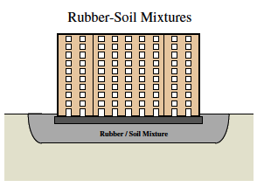
Figure 3: Schematic Example of Rubber-Soil Infill [8]

Granulated rubber-soil mixtures as a soil replacement offer many positives in theory, although some environmental complications exist in the implementation of this product. In a positive sense, a rubber-soil mixture is cheap and easy to produce, as used rubber, such as old tires or other rubber waste can be ground down into smaller pieces, resembling aggregate particles in soil. Not only does this process carry the ability to protect structures in a simple way, but it also takes care of issues with rubber waste in junkyards and landfills throughout the world. As a result, the use of old rubber as an earthquake wave reduction mechanism is extremely cost effective, as the larger rubber waste needs to only be chopped and transported, thus taking away an advanced engineering aspect typically seen in intelligent base isolation mechanisms. Due to cost effectiveness, availability, and ease in implementation, this mechanism of earthquake response reduction can be used in areas all over the world, regardless if the local area is seen as underdeveloped, developing, or advanced in terms of economic status. Environmental issues of water pollution as a result of these granulated rubber particles infiltration water sources and water tables is a valid concern; however, this issue can easily be mitigated via the implementation of some sort of synthetic barrier around the rubber-soil infill. Therefore, granulated rubber-soil mixtures seem like an extremely efficient and innovative technique for wave-energy reduction, but performance of this geotechnical base isolation mechanism will need to be explored in order to conclude that this is a usable means of structural protection [8].
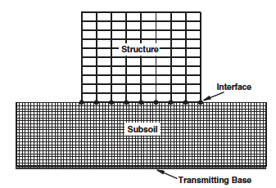
Figure 4: Experimental Test Model of Rubber-Soil infill, as seen in [8].

In order to utilize a rubber-soil composite as an infill around a structure’s base, development of a functional foundation and structure for this alternative type of geotechnical isolation system is required. A particular experiment of interest used different building widths, heights, rubber-soil composite depth, and foundation type [8]. Through experimental results generated from finite element analysis, it was determined that a wider building having a foundation without piles would perform best with a rubber soil mixture as a base [8]. Improvements to overall reduction of seismic acceleration for this particular model revealed that having a larger depth of rubber-soil composite paired with a building height between 5 and 15 stories would produce the best results [8]. Furthermore, on an average basis, the structures and modes tested in a finite element analysis program revealed that there is a 40% - 60% seismic response reduction, which is extremely significant in terms of effective seismic force reduction [11].
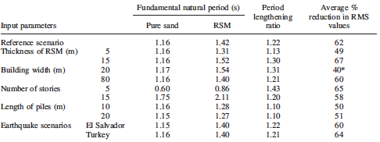
Figure 5: Reduction in Seismic Response, summary of results in [8].

Thus, the results shown for a rubber-soil mixture as a base infill prove that it is extremely effective for wave seismic response reduction and because this solution is cost effective and easy to implement, base isolation via rubber-soil mixtures is a valid form of intelligent base isolation [8].

5.2 Metamaterials in Seismic Shielding

Recent advancements in materials science has enabled the creation of metamaterials, a combination of synthetics that produce qualities that natural materials do not have the ability to accomplish. In the field of earthquake engineering, the application of metamaterials in structural design can be used to drastically reduce the effect of an earthquake event on a structure’s components, increasing the likelihood that a structure can withstand intense seismic excitation.

In respect to the topic of intelligent base design, the use of metamaterials can be applied in order to shield the structure from surface waves by modifying the geological substructure of the building site, which is a novel theory in earthquake design. Thus, unlike the common approach of base isolation from the rest of structure via mechanical methods of damping, sliding, and friction reduction, the utilization of metamaterials as a soil substitute for large scale wave protection in effect creates a seismic shield around the structure. Seismic shielding, which essentially protects the base and structure from embodied wave energy resultant of an earthquake event, presents new possibilities of earthquake resistant design, allowing for the entire building envelope to see dissipated effective seismic forces. In effect, this technology moves away from the constant overlooking of the base in seismic resistance, allowing the entirety of a structure to remain intact and less agitated than structural base isolation technology has explored, and offering a way to protect historical structures and their bases from incident surface waves [9].

The use of rubber-steel composites as a metamaterial intended for seismic shielding involves detailed analysis of the material properties behind steel and rubber. In essence, the combination of steel and rubber in a cell creates wave dispersion, which is able to produce (among many other qualities), negative refraction, cloaking, and frequency band gaps [3]. Negative refraction is useful in seismic force reduction, as the metamaterial cells would, in effect, disperse surface waves and refract negative wave signatures, reducing the amplitude of incident surface waves. In a similar way, cloaking seen in metamaterials has the ability to take incident surface waves and block certain wave signatures from passing through the material, saving the structure from surface wave excitation. Finally, the creation of frequency band gaps as a property of metamaterials enables certain ranges of frequency values to be blocked by the metamaterial, stopping certain types of incident waves from penetrating through the material. In essence, the creation of band gaps in metamaterials could be used to reduce or even block the passing of harmful wave frequencies, typically in the 1-20 Hz range for earthquakes, from reaching the base of the structure [9]. Clearly, this form of technology has the ability to introduce a novel science in earthquake resistant design, which will be explored.

A novel experiment conducted on large scale mechanical metamaterials is particularly interesting in relation to the development and implementation of an exterior earthquake resistant lattice, designed to dissipate wave effects and create frequency band gaps around a structure that is located in an area with a dissipative sandy soil geology [9]. In this experiment, three types of metamaterials are tested, which offer different methods of earthquake wave reduction techniques. The first metamaterial is a cross shaped cavity which, in previous testing, had proven to be effective in inducing large frequency band gaps, thus resulting in frequency shielding for a typical earthquake wave signature. The second metamaterial is a hollow cylinder made out of steel, which reduces overall earthquake effects and is simple to implement around a base. The third and final metamaterial tested was a steel, rubber, and soil cell, consisting of a rubber wrapped steel tube, and was chosen due to its ability to generate wavelengths shorter than those seen typically in earthquakes, another characteristic of frequency band gapping. The multiple methods of seismic shielding presented in this experiment were modeled using finite element analysis, instead of an actual field test, which was important to note [9].
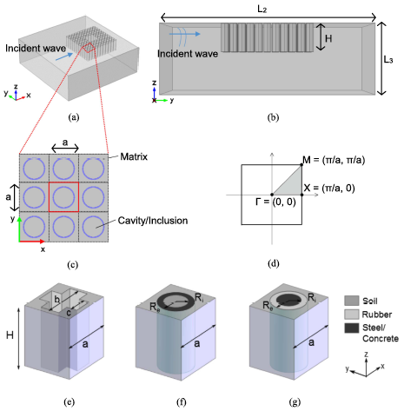
Figure 6: Experimental Design of Metamaterials, as seen in [9]

After the three metamaterial models were tested, multiple results were produced for different wave types incident after an earthquake; however, for analysis of sufficient effectiveness of these structures it is only necessary to investigate performance under surface wave excitation, as a majority of all embodied energy in an earthquake results in these destructive wave signatures. Experimental results showed that the cross shaped cell metamaterial performed the best for surface waves; however, the design of these cross shaped cavities was recommended to be modified so that a layer of higher strength material, such as aluminum, should be used to reinforce the barrier between the soil and the cavity, as the rigidity of the overall construction could be increased. Although the effects of this are inconsistent with the original design concept, the addition of a more rigid material to the construction of these cells would slightly increase the frequencies that the band gaps would cover. Thus, for the most part, the frequency band gap that was experimentally tested would shift up to a higher range in frequencies, which is justified considering the large range of frequencies that an earthquake can produce.
Experimental results yielded that the cross-shaped cavity creates a virtually impenetrable area around the base of the structure for wave signatures centered around 5 Hz, with a frequency range of 1 Hz to 10 Hz tested [9]. Moreover, it was observed that each row of metamaterial cells dissipated incident wave energy exponentially and this observation remained true for a range of earthquakes that could be classified for a devastating earthquake event (level X) to moderate earthquakes (level VII) [9]. The experimental results continued to reveal that these large scale mechanical metamaterials shift the overall fundamental frequency of earthquake waves to a lower energy threshold, reducing overall seismic effects.
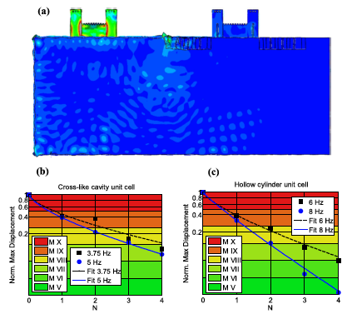
Figure 7: Stresses shown (maximum = red, minimum = blue) in a metamaterial protected structure vs. a non-protected structure, as shown in [9].

The experiment continues to recommend that for real world application, a series of design steps and considerations must be considered in order to choose the best possible metamaterial structure for earthquake wave reduction, depending on a multitude of factors such as soil structure and typical local earthquake wave modes. Thus, these mechanical metamaterials can be designed locally in an efficient and cost effective manner for earthquake wave dissipation, and structure can be easily changed based on project size and site area. Furthermore, these metamaterials can easily be implanted into existing soil substructure for both cases of post construction application or pre construction application. It was found that for a matrix of 4 rows of metamaterials surrounding the structure, the initial embodied wave energy would be decreased in severity by approximately 5 magnitudes once the wave reached the actual structure, resulting in low level damage to poorly designed structures, thus keeping well designed structures largely intact and free of even moderate earthquake wave excitation [9]. As evidenced by this experiment, the prospect of future metamaterial utilization in structural protection is both beneficial and feasible, offering a new and unique alternative for intelligent base isolation that can be applied to the entire building envelope [9].

6. Conclusions

Various types of intelligent base isolation methods offer differing concepts in earthquake wave reduction due to their construction and implementation, thus effecting their ability to reduce resultant seismic forces within a structure. A summary of major intelligent base isolation technologies and their overall effectiveness can be seen below.

- Older and more commonly used base isolation techniques, which are those in the structural base isolation category, offer room for improvement in design and can have valuable applications as technology develops in the future. Ideally, these structural base isolation techniques should evolve from conventional, purely mechanical forms, to be paired with computerization in order to optimize performance in a multitude of earthquake scenarios. Since each earthquake has a different magnitude, wave signature, and frequency, structural base isolators tend to lack proficiency in full structural protection due to the design of these mechanisms only covering blanket cases and a certain range of frequencies. Thus, if paired with computerization, these systems would have the ability to modify the effective stiffness of structural base isolators for damping, and could have the ability to modify friction coefficients for sliding and friction applications. Thus, although proven effective in design, these elements have room for future improvement.

- In an alternative fashion, geotechnical base isolation techniques offer a more protective barrier for earthquake waves due to their implementation around a structure’s envelope. As these methods are designed to protect the entire structure, including the foundation, it is more likely that a structure will see less damage due to wave reduction being accomplished prior to forces being taken by the foundation. Research findings suggest that both rubber-soil mixtures and mechanical metamaterials have the ability to greatly reduce peak accelerations and thus resultant shear forces and moments in main structural elements. Rubber-soil composites were found to offer a 40%-60% reduction in seismic response while offering ease of implementation in a cost effective manner. Furthermore, rubber-soil composites solve issues of rubber waste in a positive way: by helping to save structures from destruction in a severe earthquake event. Similarly, mechanical metamaterials offer extreme structural protection via frequency band gapping and can reduce wave energy by up to 5 magnitudes prior to contact with a structure. Mechanical metamaterials can be easily implemented to protect existing structures in retrofit, while maintaining simplicity in design. Therefore, this field of base isolation, although still developing, provides hope for future geotechnical base isolation advancements and is truly an intelligent form of base isolation.

- Finally, computerized methods of base isolation are relevant to intelligent base isolation, as this is the most optimal way to protect a structure. Computerized systems can modify stiffness and friction within a structure, allowing for the structure to have less response in the event of an earthquake, optimizing building performance and protection. Although further development in computerization is needed to improve feedback loops and response time, adjustments in stiffness at beam-column connections for resultant wave frequencies prove to save structures in the event of a severe earthquake. As results of semi-active control tests suggest, these base isolation systems have the ability to reduce deformation of floors by 3 to 4 times of what could be expected without an intelligent base isolation system. Therefore, this method can be seen as a truly intelligent way to protect structures and can be developed in unison with structural and geotechnical base isolation methods to produce ideal intelligent base isolation systems.

Geotechnical and computerized methods of base isolation embody ideas of intelligent base isolation and consequently have the highest rates of seismic response reduction in structures, making them the best methods for structural protection. It is recommended that in the future, these methods should develop to either become more optimal on their own, or be paired together in order to create an integrated response system that lessens effective earthquake effects by multiple magnitudes.

Appendix – References

[1] Nagarajaiah, Satish, and Sun Xiaohong. "Response of Base-Isolated USC Hospital Building in Northridge Earthquake." Journal of Structural Engineering 126.10 (2000): 1177-186. Web.
[2] GiÄev, Vlado, and Mihailo D. Trifunac. "Energy Dissipation by Nonlinear Soil Strains during Soilâ€“structure Interaction Excited by SH Pulse." Soil Dynamics and Earthquake Engineering 43 (2012): 261-70. Web.

[3] Lesgidis, Nikolaos, Anastasios Sextos, and Oh-Sung Kwon. "Influence of Frequency-dependent Soil-structure Interaction on the Fragility of R/C Bridges." Earthquake Engineering & Structural Dynamics 46.1 (2016): 139-58. Web. 24 Feb. 2017.
[4] Stehmeyer, Edward H., and Dimitris C. Rizos. "Considering Dynamic Soil Structure Interaction (SSI) Effects on Seismic Isolation Retrofit Efficiency and the Importance of Natural Frequency Ratio." Soil Dynamics and Earthquake Engineering 28.6 (2008): 468-79. Web.
[5] Tongaonkar, N.p., and R.s. Jangid. "Seismic Response of Isolated Bridges with Soilâ€“structure Interaction." Soil Dynamics and Earthquake Engineering 23.4 (2003): 287-302. Web.

[6] Aldaikh, Hesham, Nicholas A. Alexander, Erdin Ibraim, and Jonathan Knappett. "Shake Table Testing of the Dynamic Interaction between Two and Three Adjacent Buildings (SSSI)." Soil Dynamics and Earthquake Engineering 89 (2016): 219-32. Web.
[7] Alli, Hasan, and OÄŸuz Yakut. "Fuzzy Sliding-mode Control of Structures." Engineering Structures 27.2 (2005): 277-84. Web.

[9] Miniaci, Marco, Anastasiia Krushynska, Federico Bosia, and Nicola M. Pugno. "Large Scale Mechanical Metamaterials as Seismic Shields." New Journal of Physics 18.8 (2016): 083041. Web.
[8] Tsang, Hing-Ho, S. H. Lo, X. Xu, and M. Neaz Sheikh. "Seismic Isolation for Low-to-medium-rise Buildings Using Granulated Rubber-soil Mixtures: Numerical Study." Earthquake Engineering & Structural Dynamics 41.14 (2012): 2009-024. Web.
[9] Miniaci, Marco, Anastasiia Krushynska, Federico Bosia, and Nicola M. Pugno. "Large Scale Mechanical Metamaterials as Seismic Shields." New Journal of Physics 18.8 (2016): 083041. Web.
[10] Matsagar, Vasant A., and R.s. Jangid. "Seismic Response of Base-isolated Structures during Impact with Adjacent Structures." Engineering Structures 25.10 (2003): 1311-323. Web.

